Today I AM FEELING
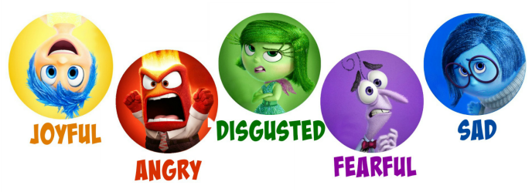
BECAUSE...
I feel
when...
when...
when...
when...
When...

Draw a time you felt...

Draw a memory sphere for each emotion.

JOY |  |  | SADNESS
 | DISGUST
FEAR |  |  | ANGER

